**User Manual**

Market Magician

Fall 2025

Artificial Asynchrony

Table of Contents

Introduction..................................................................... 3

Getting Started

I. Application without an Account .............................. 4

II. Logging into your Account ..................................... 5 III. Creating an Account ............................................. 6

Navigation

I. Home .................................................................... 7

II. Buy Stocks ........................................................... 8

II. Search Ticker ........................................................ 9

Profile

I. Logout of Account ................................................ 10

Introduction

Welcome to the user manual for the Market Magician application. This manual is designed to provide a complete step-by-step guide for any user who wants to use our application. This application is intended for investors and traders. Market Magician uses algorithms and deep learning to make predictions on stocks. By providing predictive capabilities, our application provides an easy way to invest and trade while also minimizing risk and maximizing user profits.

Getting Started

Before using Market Magician, a user must create an account. Having a personal account enables a user to trade and buy stocks. Without an account, a user will not be able to access all the features of the application.

1. Application without an Account

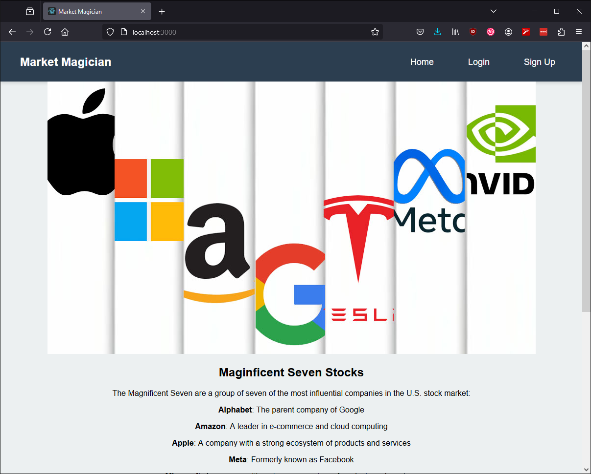

1. Logging into your account

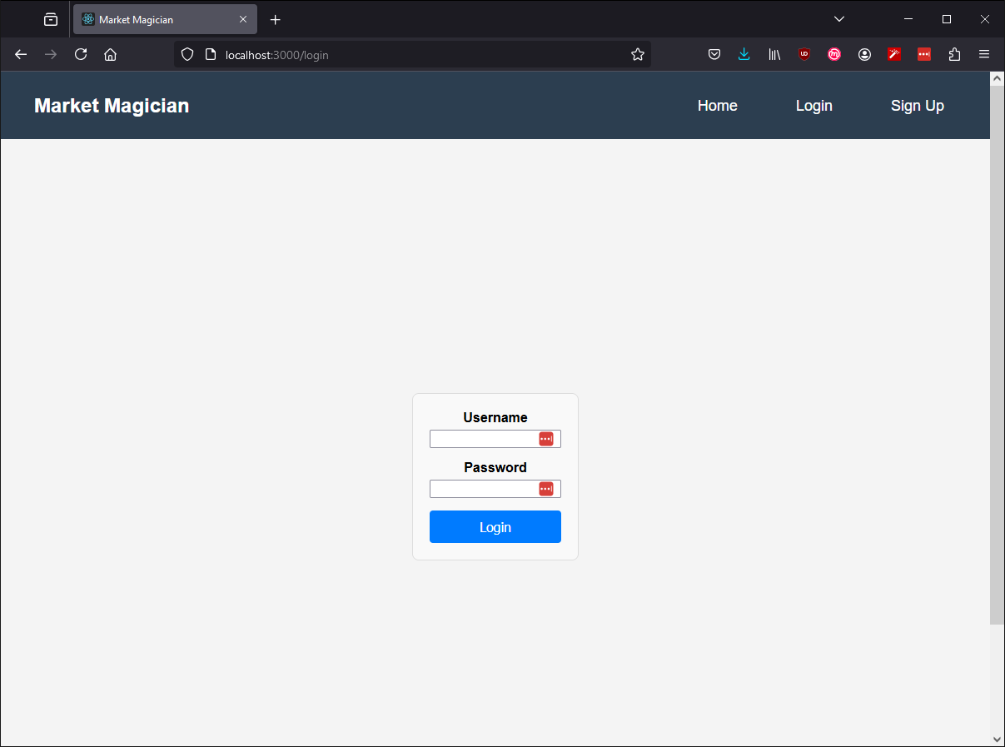

1. Select “Login on the top right”. After selecting the “Login”, you will be redirected to the following screen.
2. After you input your credentials, which are the username and password, you click the “Login” button in blue.

By following these steps, you will be logged into your account.

III. Creating an Account

If you have not registered an account on Market Magician, the following steps guide you on creating one.

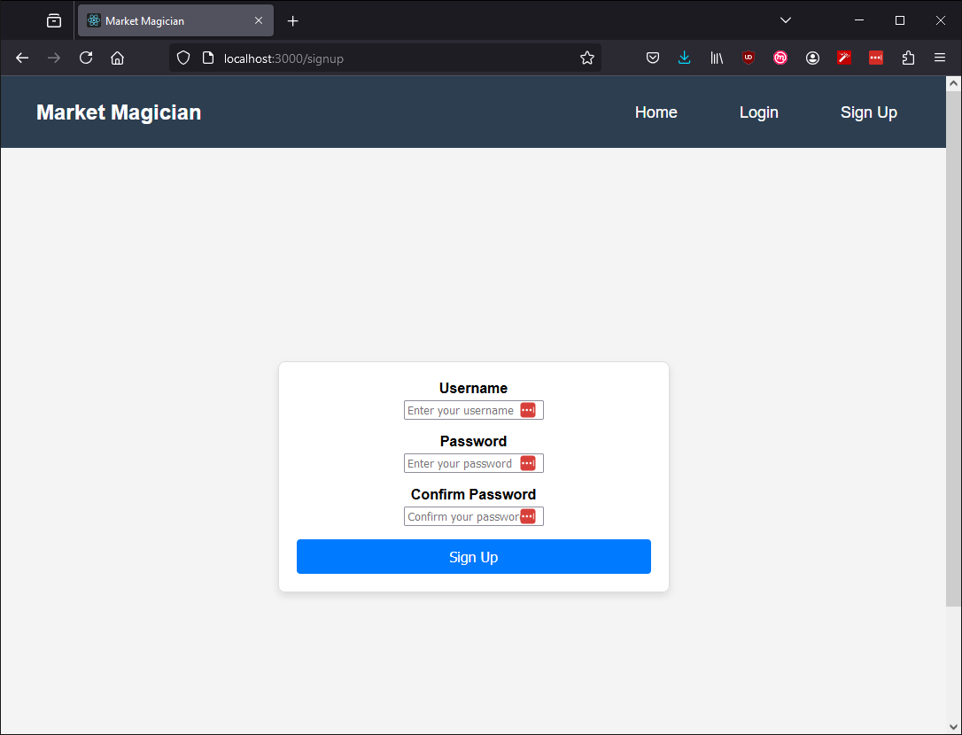

1. Select “Sign Up” at the top right of the page.
2. Enter a unique “Username”.
3. Enter a unique “Password”.
4. Re-enter the same “Password”, the passwords must be the same or you will receive an error message.

Navigation

Once you have logged into your account, you are able to access all of the applications features.

1. Home

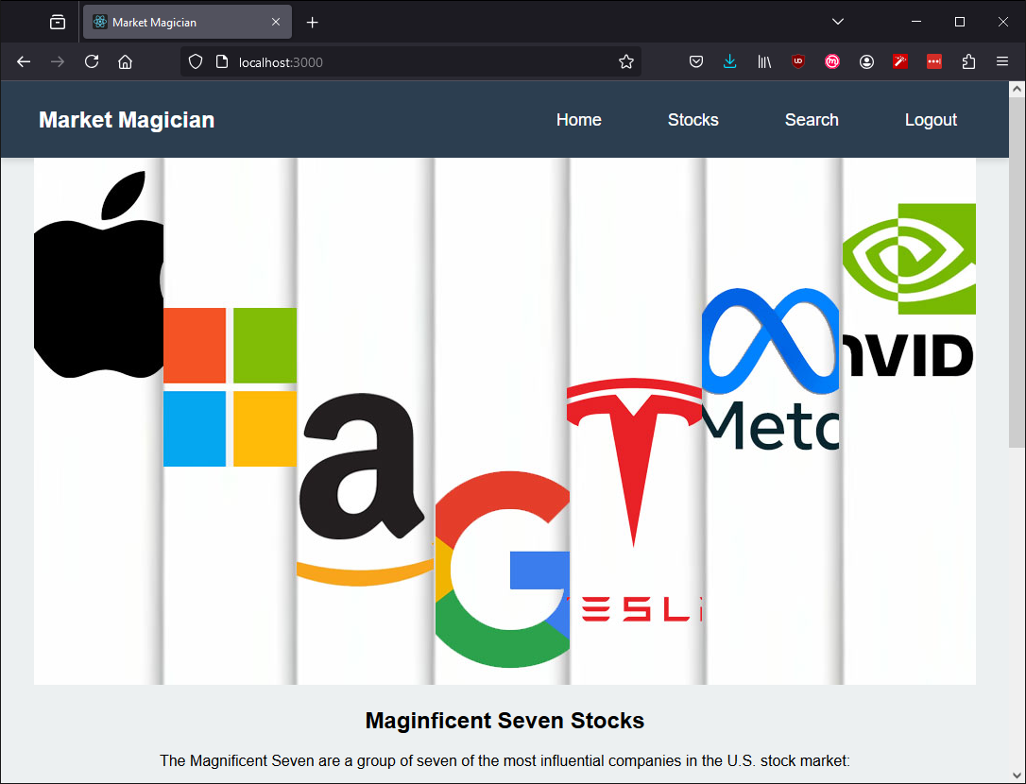

This screen displays all of the features available on the navigation bar of the home page. The top right of the navigation bar now includes the option for “Stocks”, “Search”, and “Logout”.

1. Buy Stocks

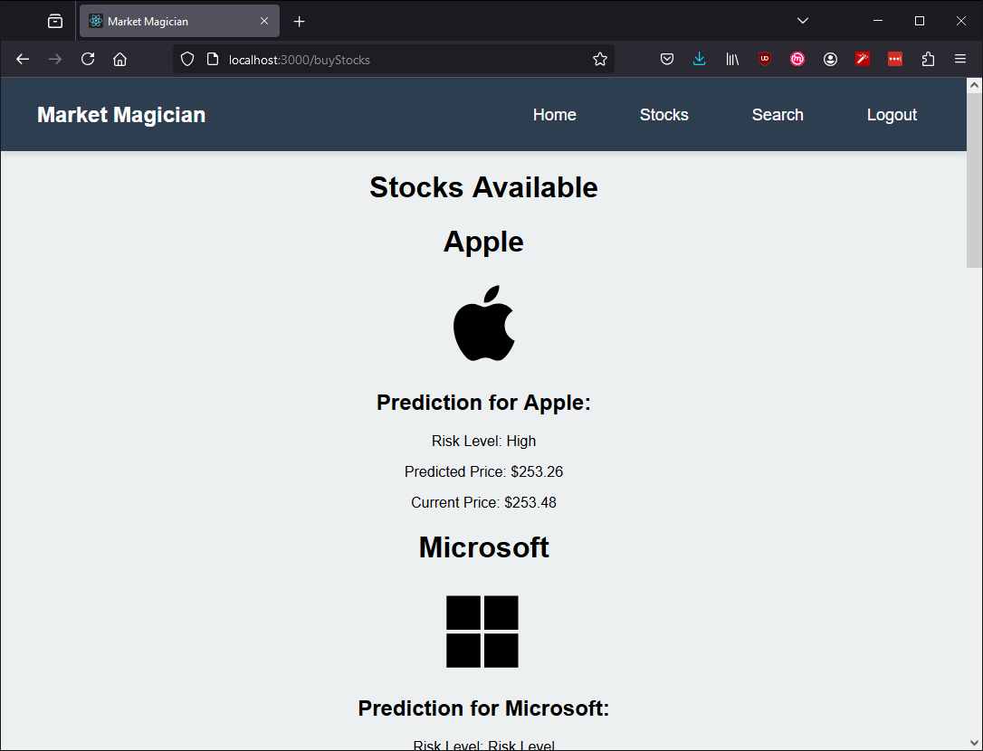

Selecting the “Stocks” page on the navigation bar takes you to the above screenshot. On this page, you click on whichever stock image you’d like. In this example, the user selected the Apple Icon which produced the prediction price for the Apple stock.

III. Search Ticker

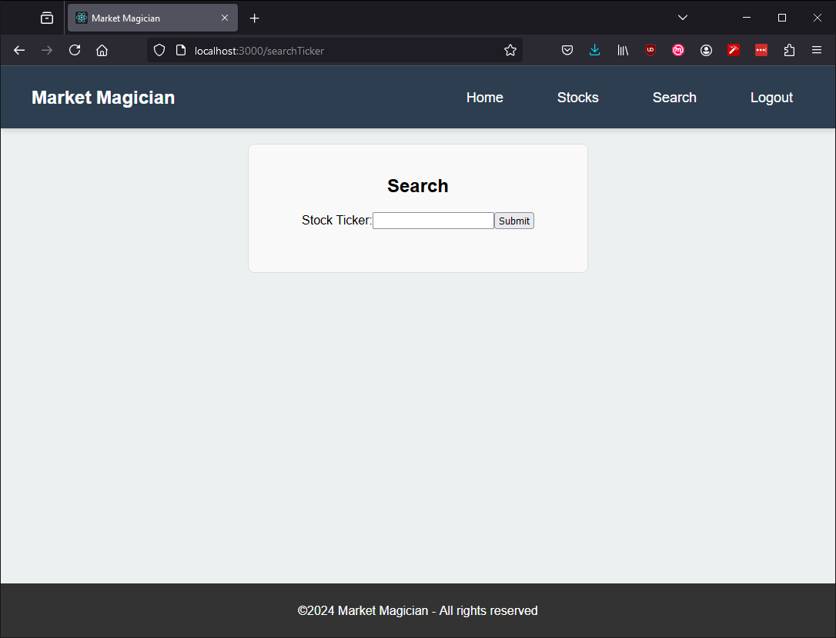

Selecting the “Search” page on the navigation bar takes you to the above screenshot.

On this page, you can input whatever valid ticker you’d like. If the application recognizes the input ticker as a valid stock, it will display the stock information for that ticker.

Profile

1. Logout



1. Select the “Logout” page on the navigation bar.
2. Once selected, the Market Magician application will revert to the home screen with the missing navigation pages of “Stocks”, “Search”, and “Logout”.